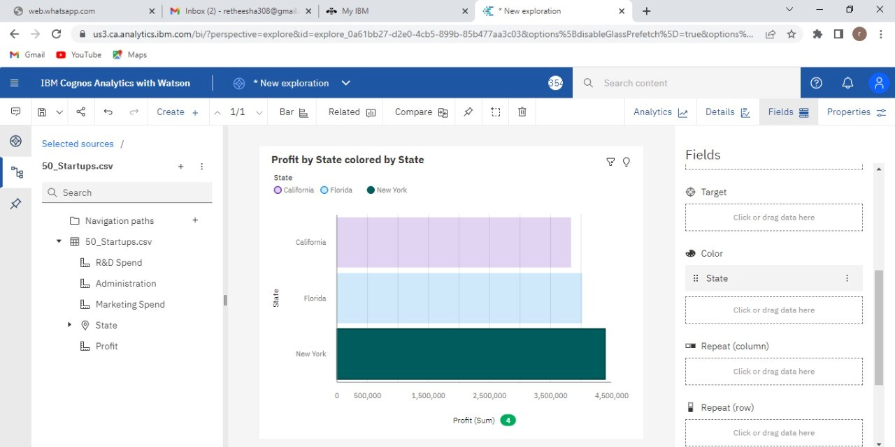Profit (Sum) O

* Selected sources

Profit by State o Fields

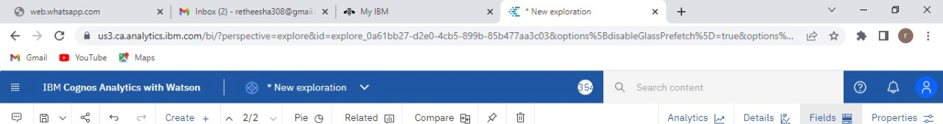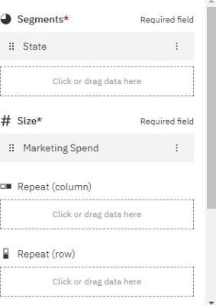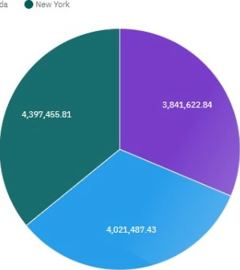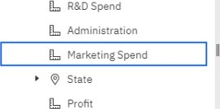 California Florida

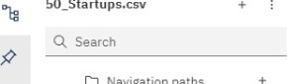

C]

Navigation

paths

so Startups.csv

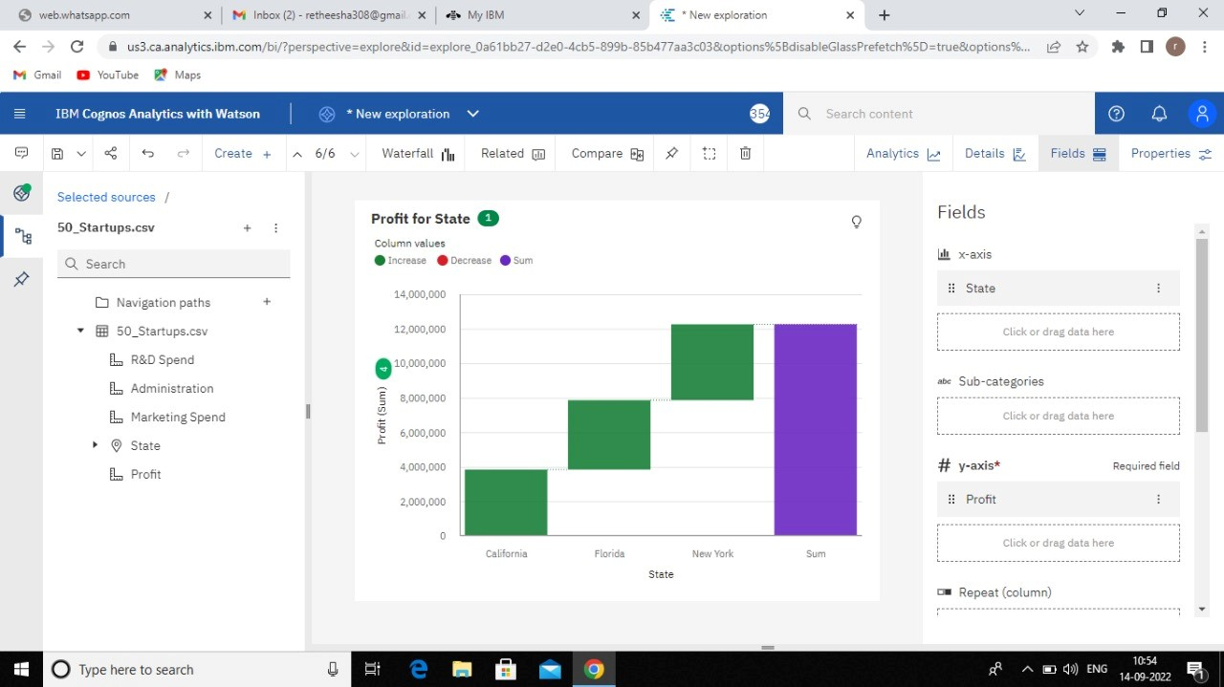

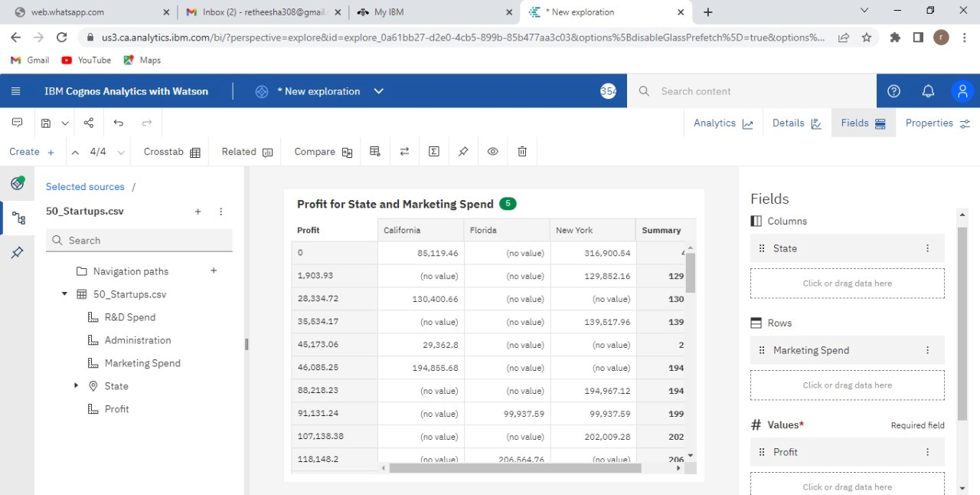



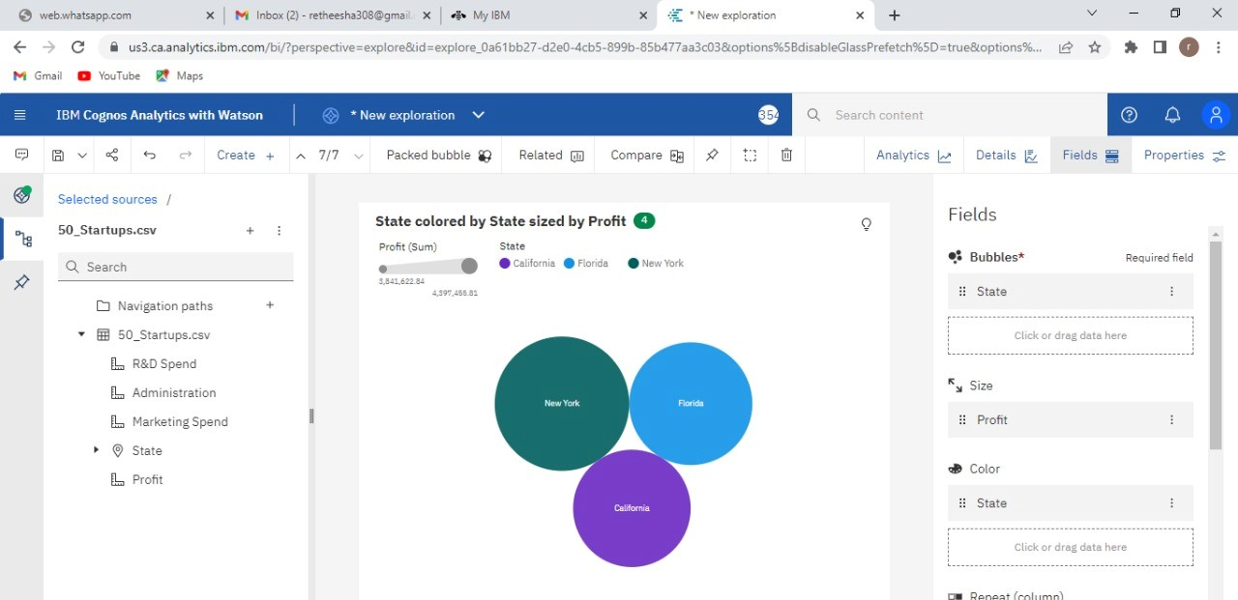

Repeat

(column)

* Selected sources

Marketing Spend by State colored by State o

California FloridaNew Wk

# y-axis* Required field

so Startups.csv

R&D Spend

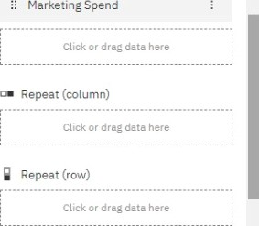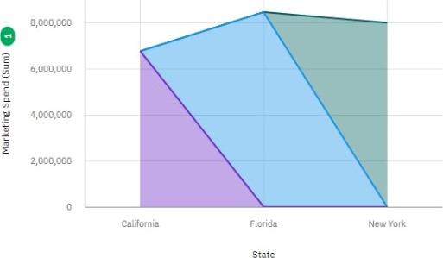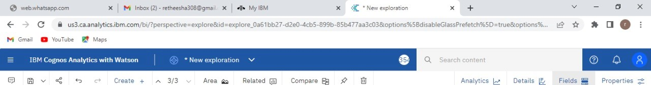Administration



C]

Navigation

paths

Marketing Spend

State

Of-it

# Tooltip

Fields